NewSpace Winter School
Date: February 10-14, 2026
The NewSpace Winter School, organised by Espaço ao Cubo, is a week-long course designed for university students with an interest in Physics, Engineering, Space Technologies, Management and Space Law.

About the program
Over a period of five days, participants will take part in themed lectures and workshop sessions focused on the main pillars of the NewSpace ecosystem. Each block combines theoretical foundations with practical learning, fostering technical knowledge, interdisciplinary thinking and creative problem-solving skills.

Thematic Blocks
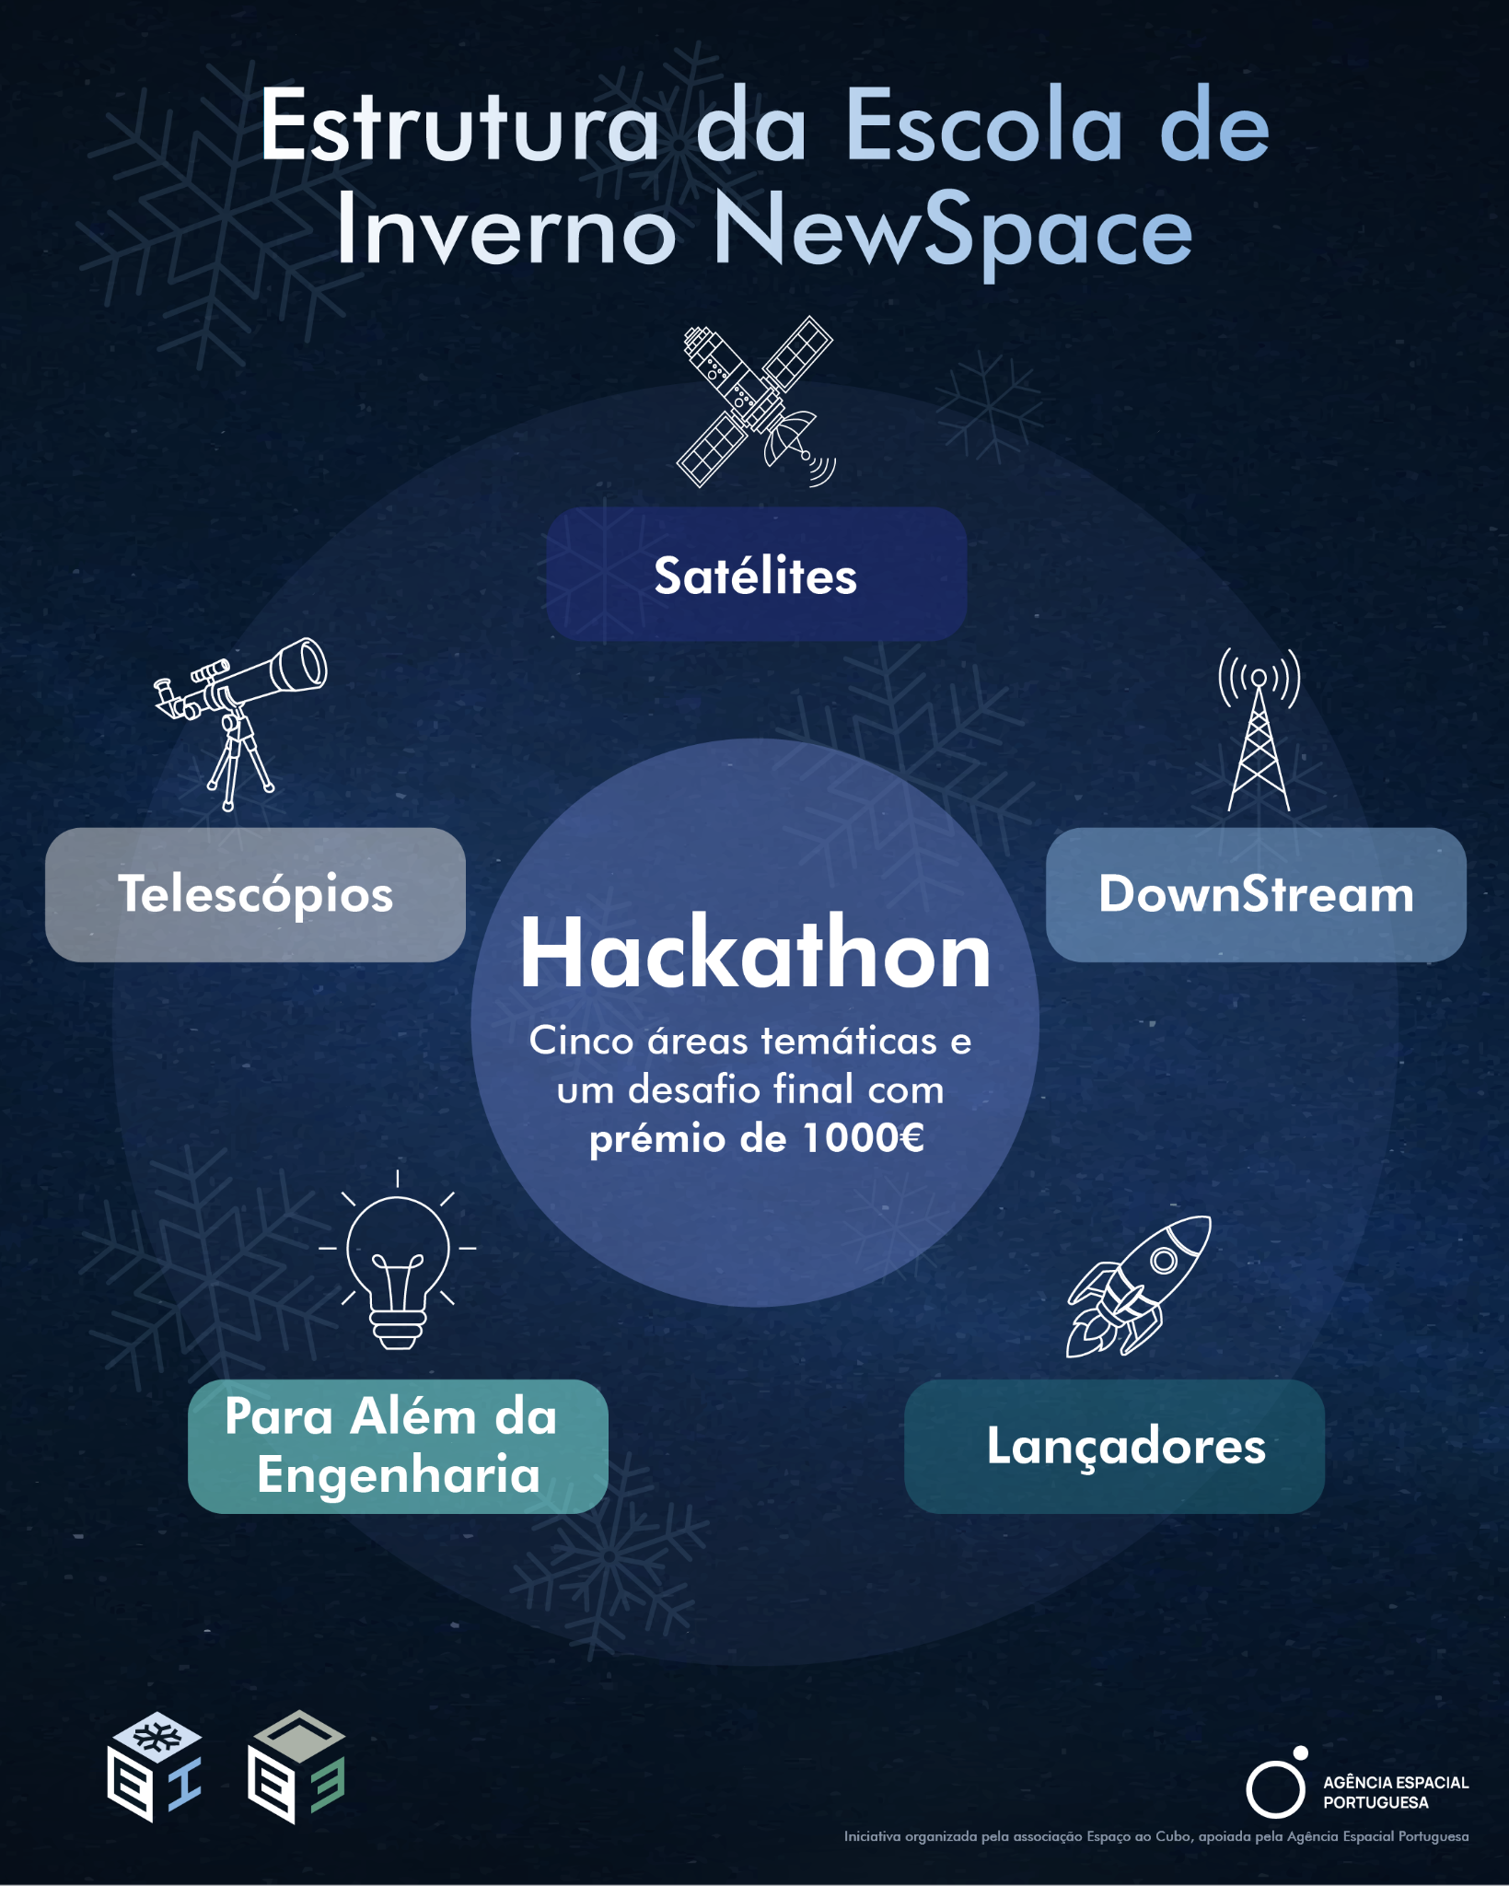
🔭 TELESCOPES – Explore space observation through an approach focused on instrumentation and astrophysical research, engaging with telescope systems, data collection and scientific analysis.
🛰️ SATELLITES – Address the main satellite development processes and the current NewSpace trends, covering design, orbital mechanics and modern applications.
🌐 DOWNSTREAM – Dedicated to the applications of satellite data, focusing on the practical use of space-based information for technological, commercial and sustainable solutions.
🚀 LAUNCH SYSTEMS – Explore the various existing launch vehicles, with a special focus on emerging technologies and their role within the NewSpace sector.
📈 BEYOND ENGINEERING – A cross-cutting block covering management, science communication, entrepreneurship in science and space law, enhancing participants’ understanding of the broader space industry.
💡 HACKATHON – The Winter School concludes with a 24-hour Hackathon, where multidisciplinary teams apply the knowledge acquired throughout the week to develop a creative NewSpace-related project.

Schedule
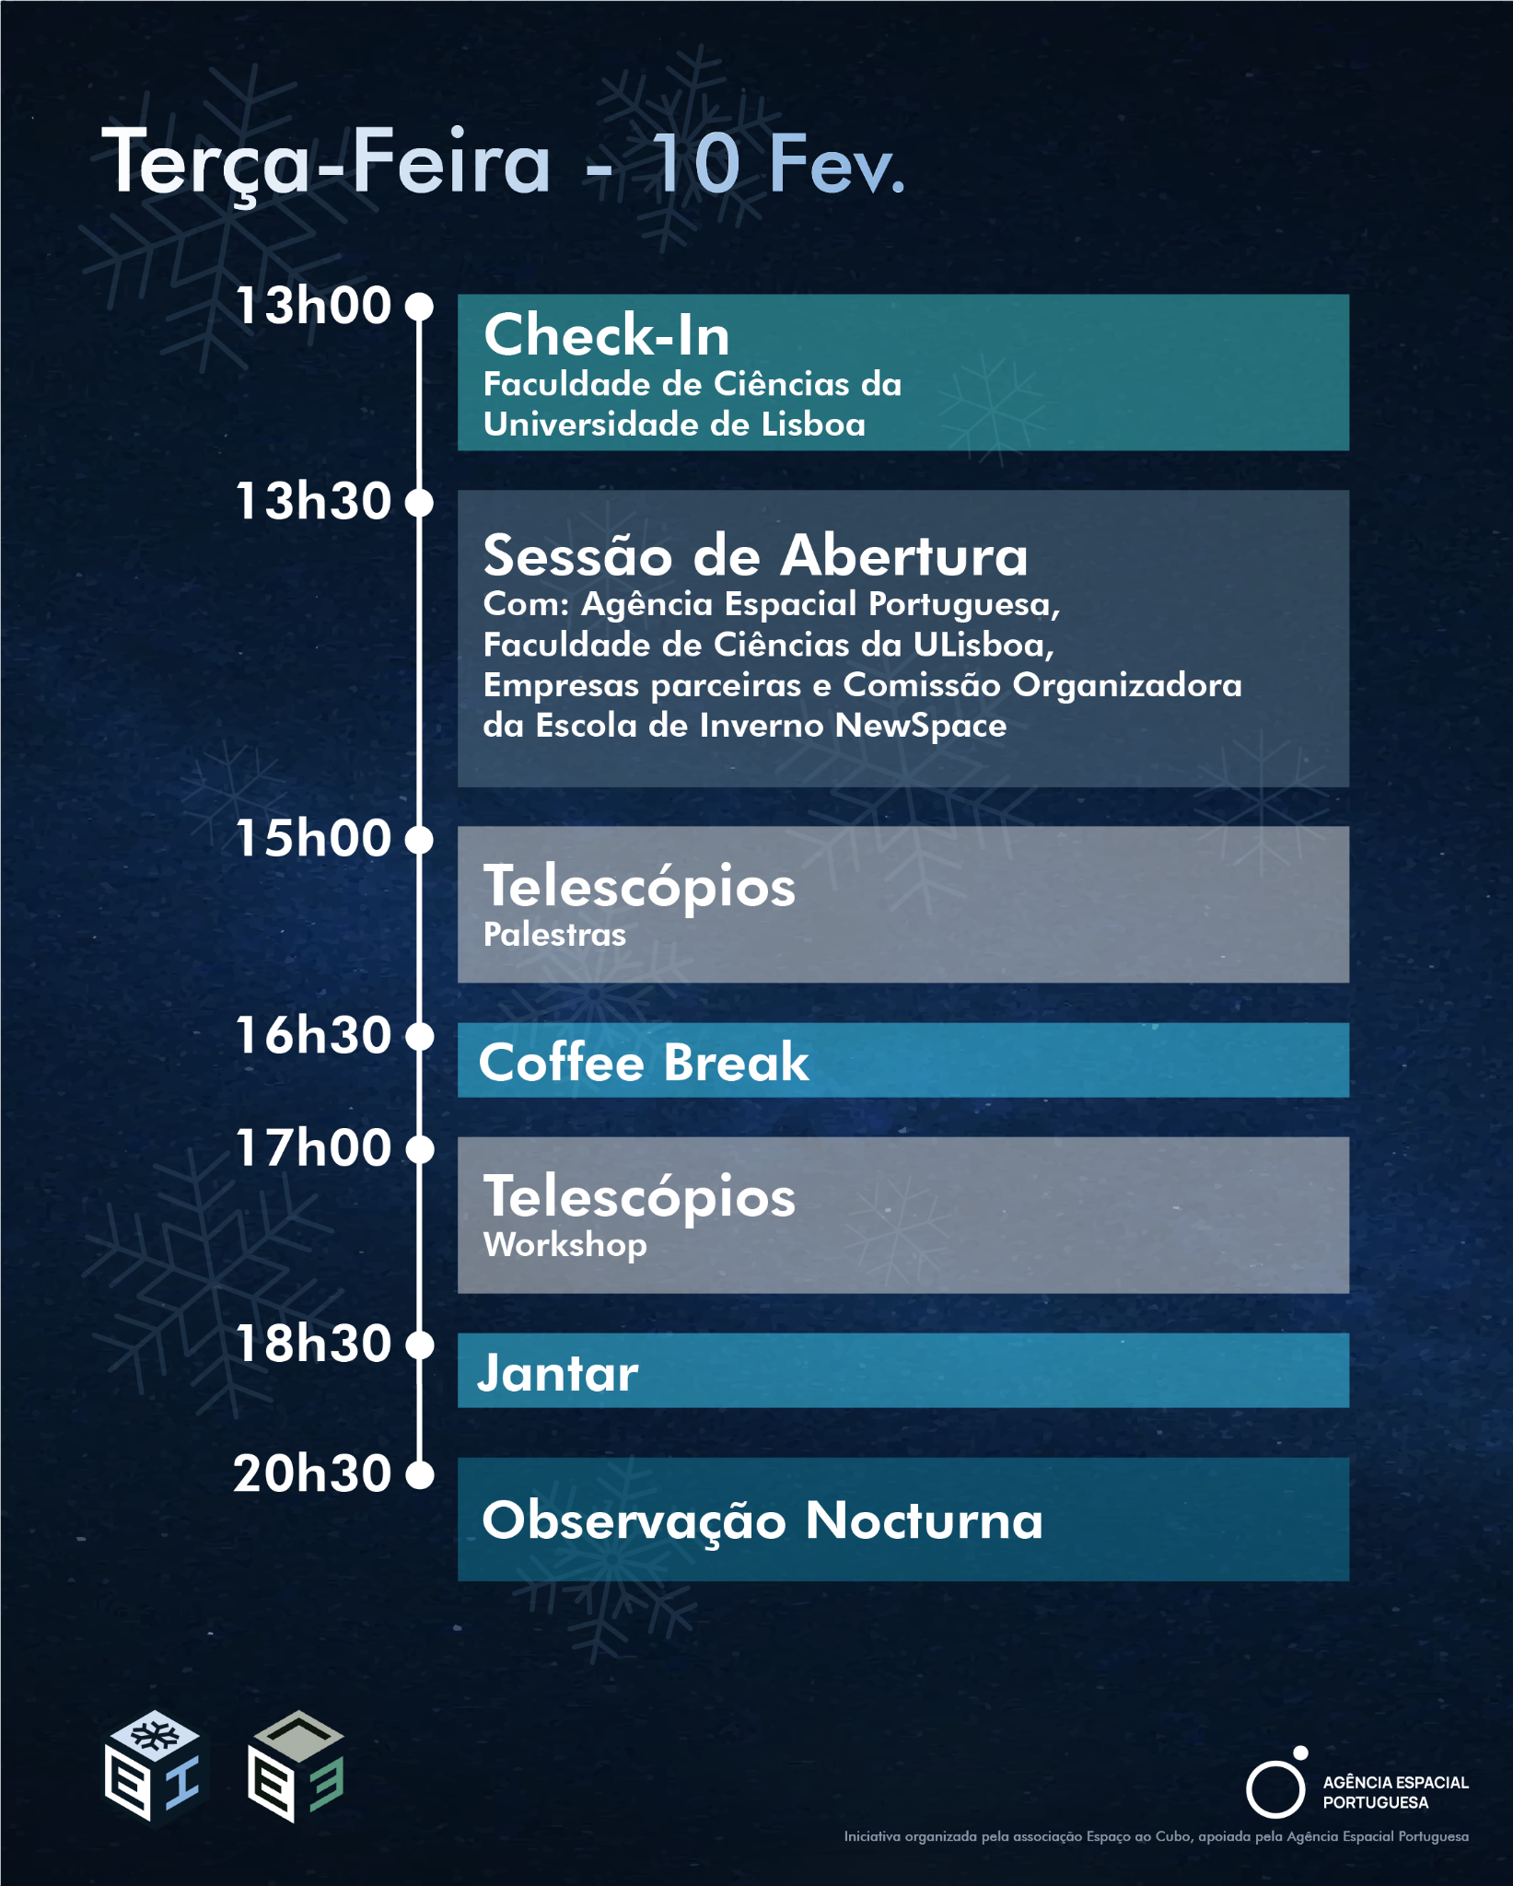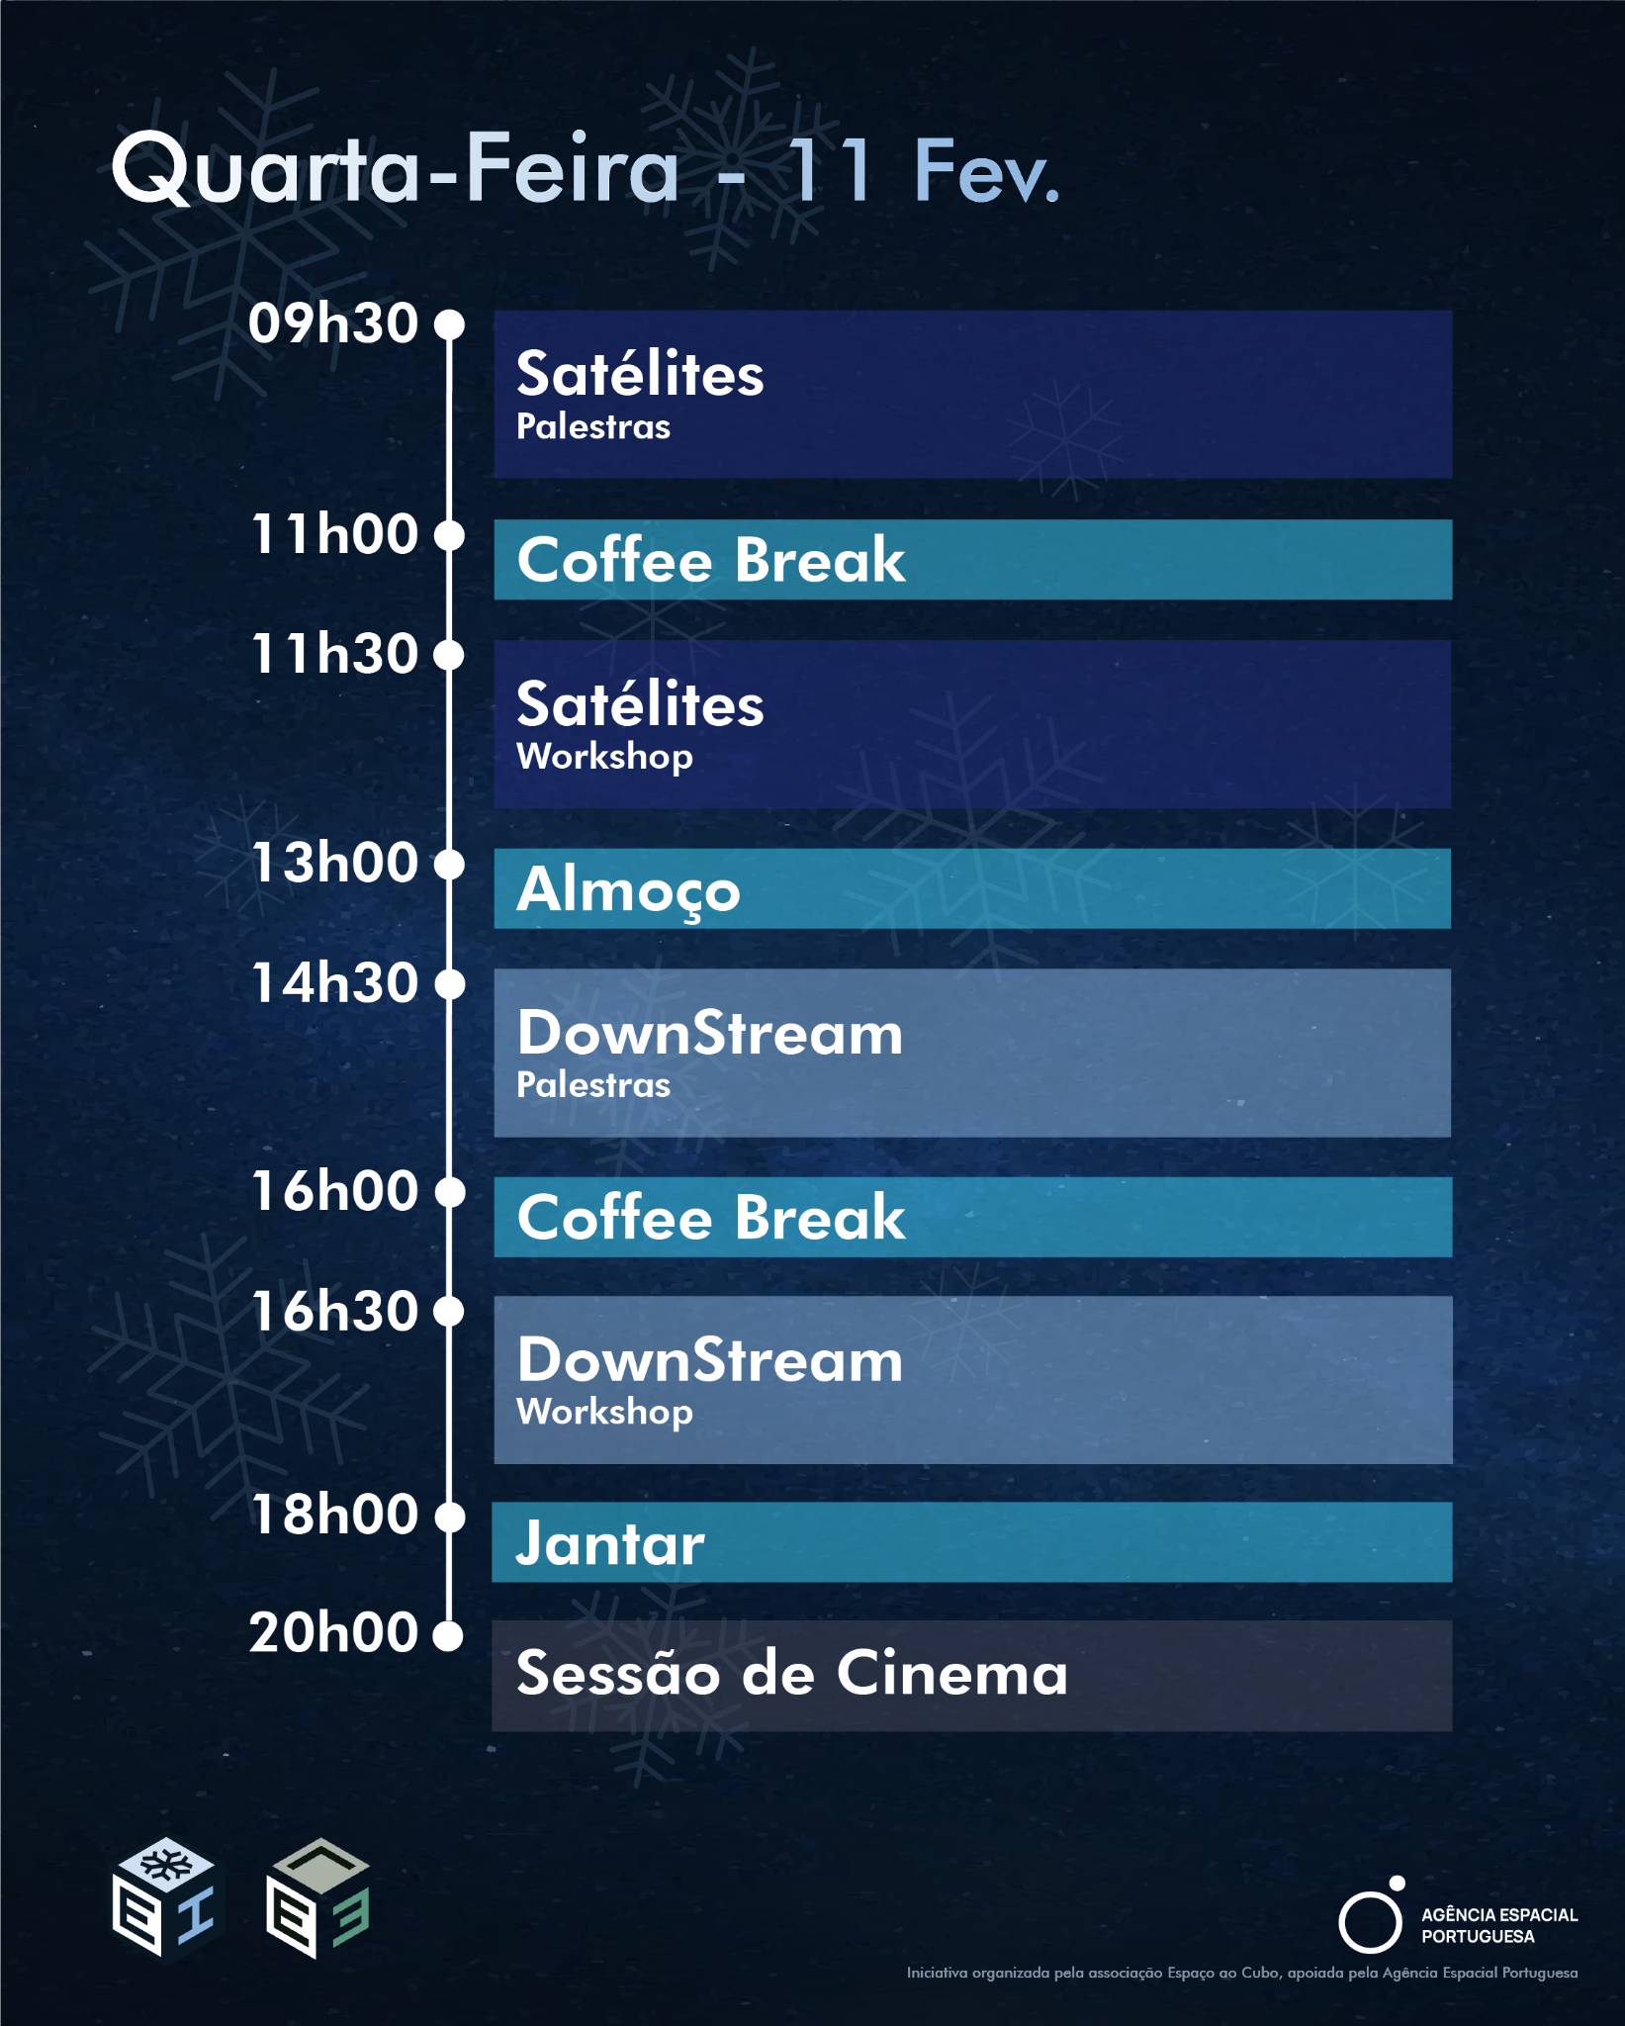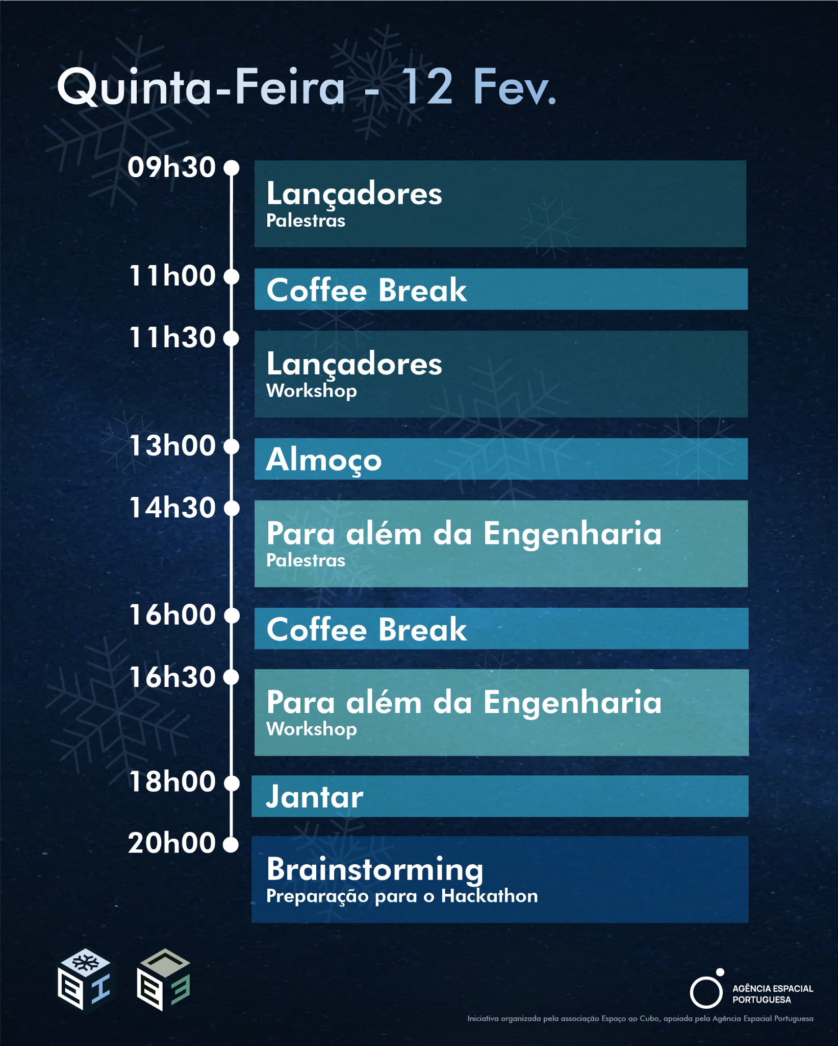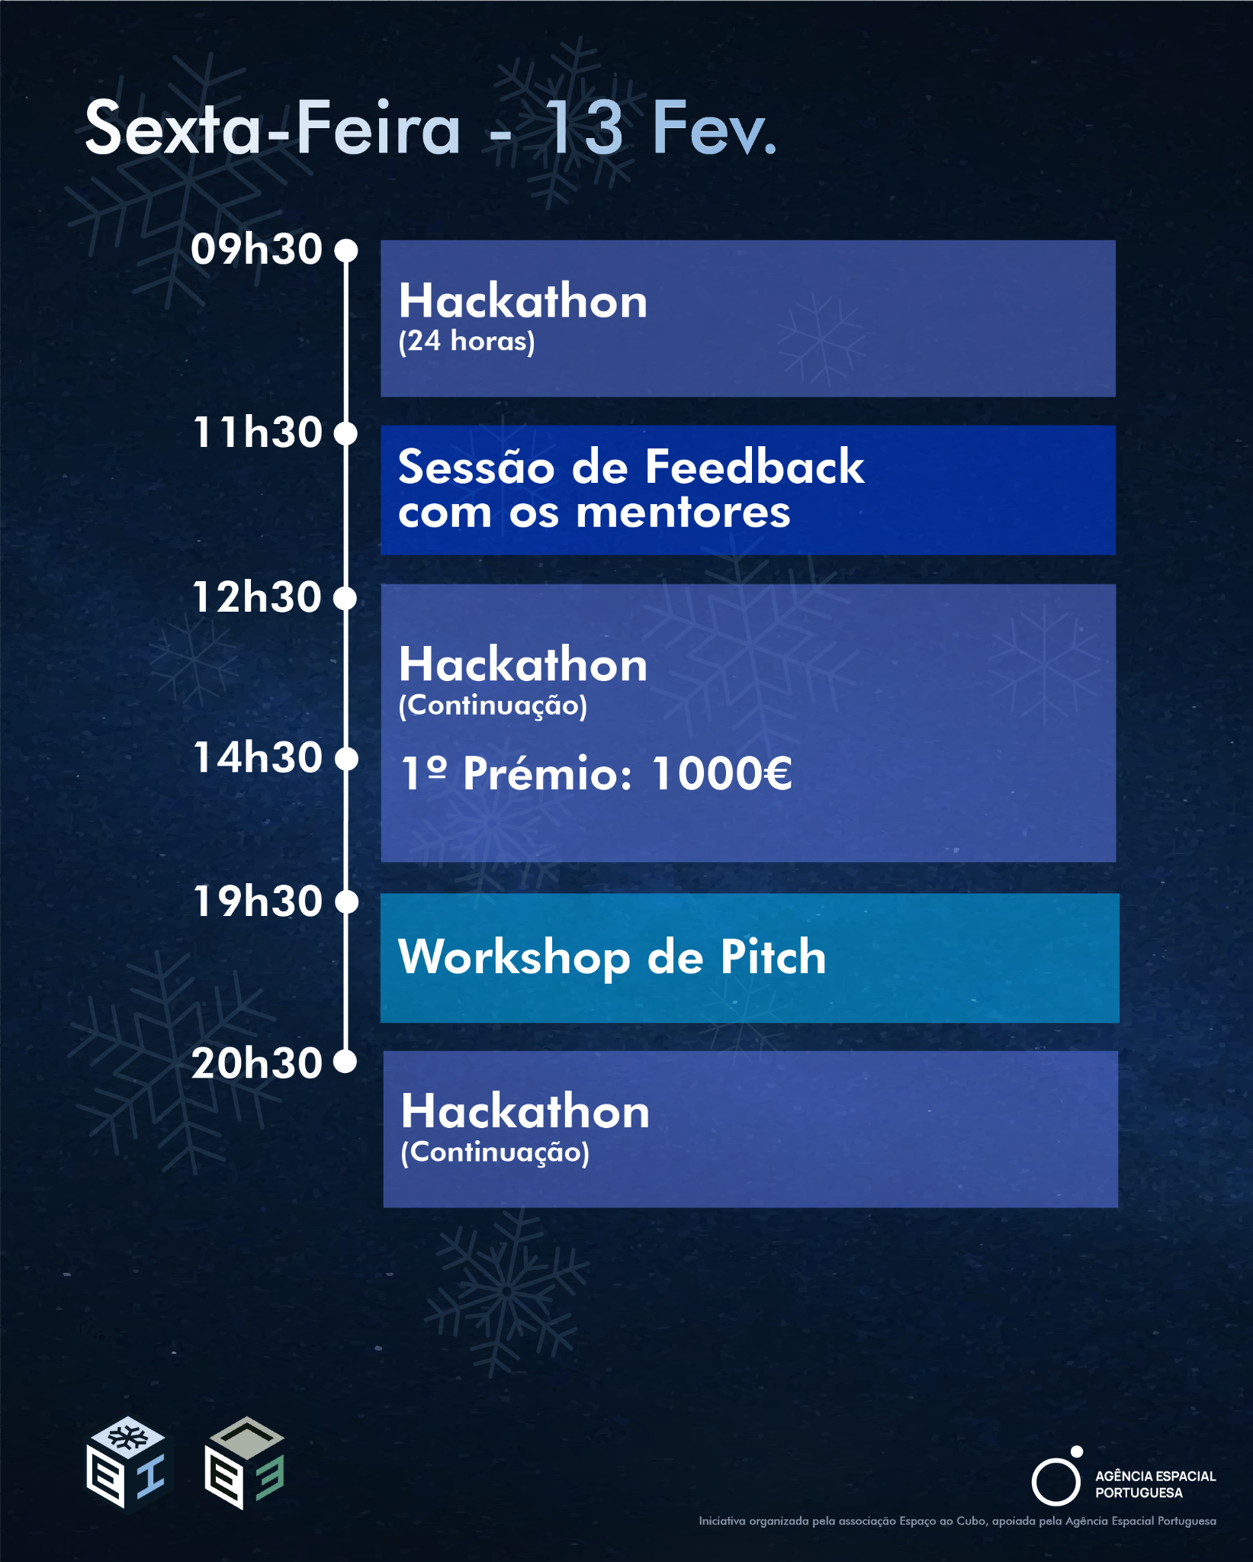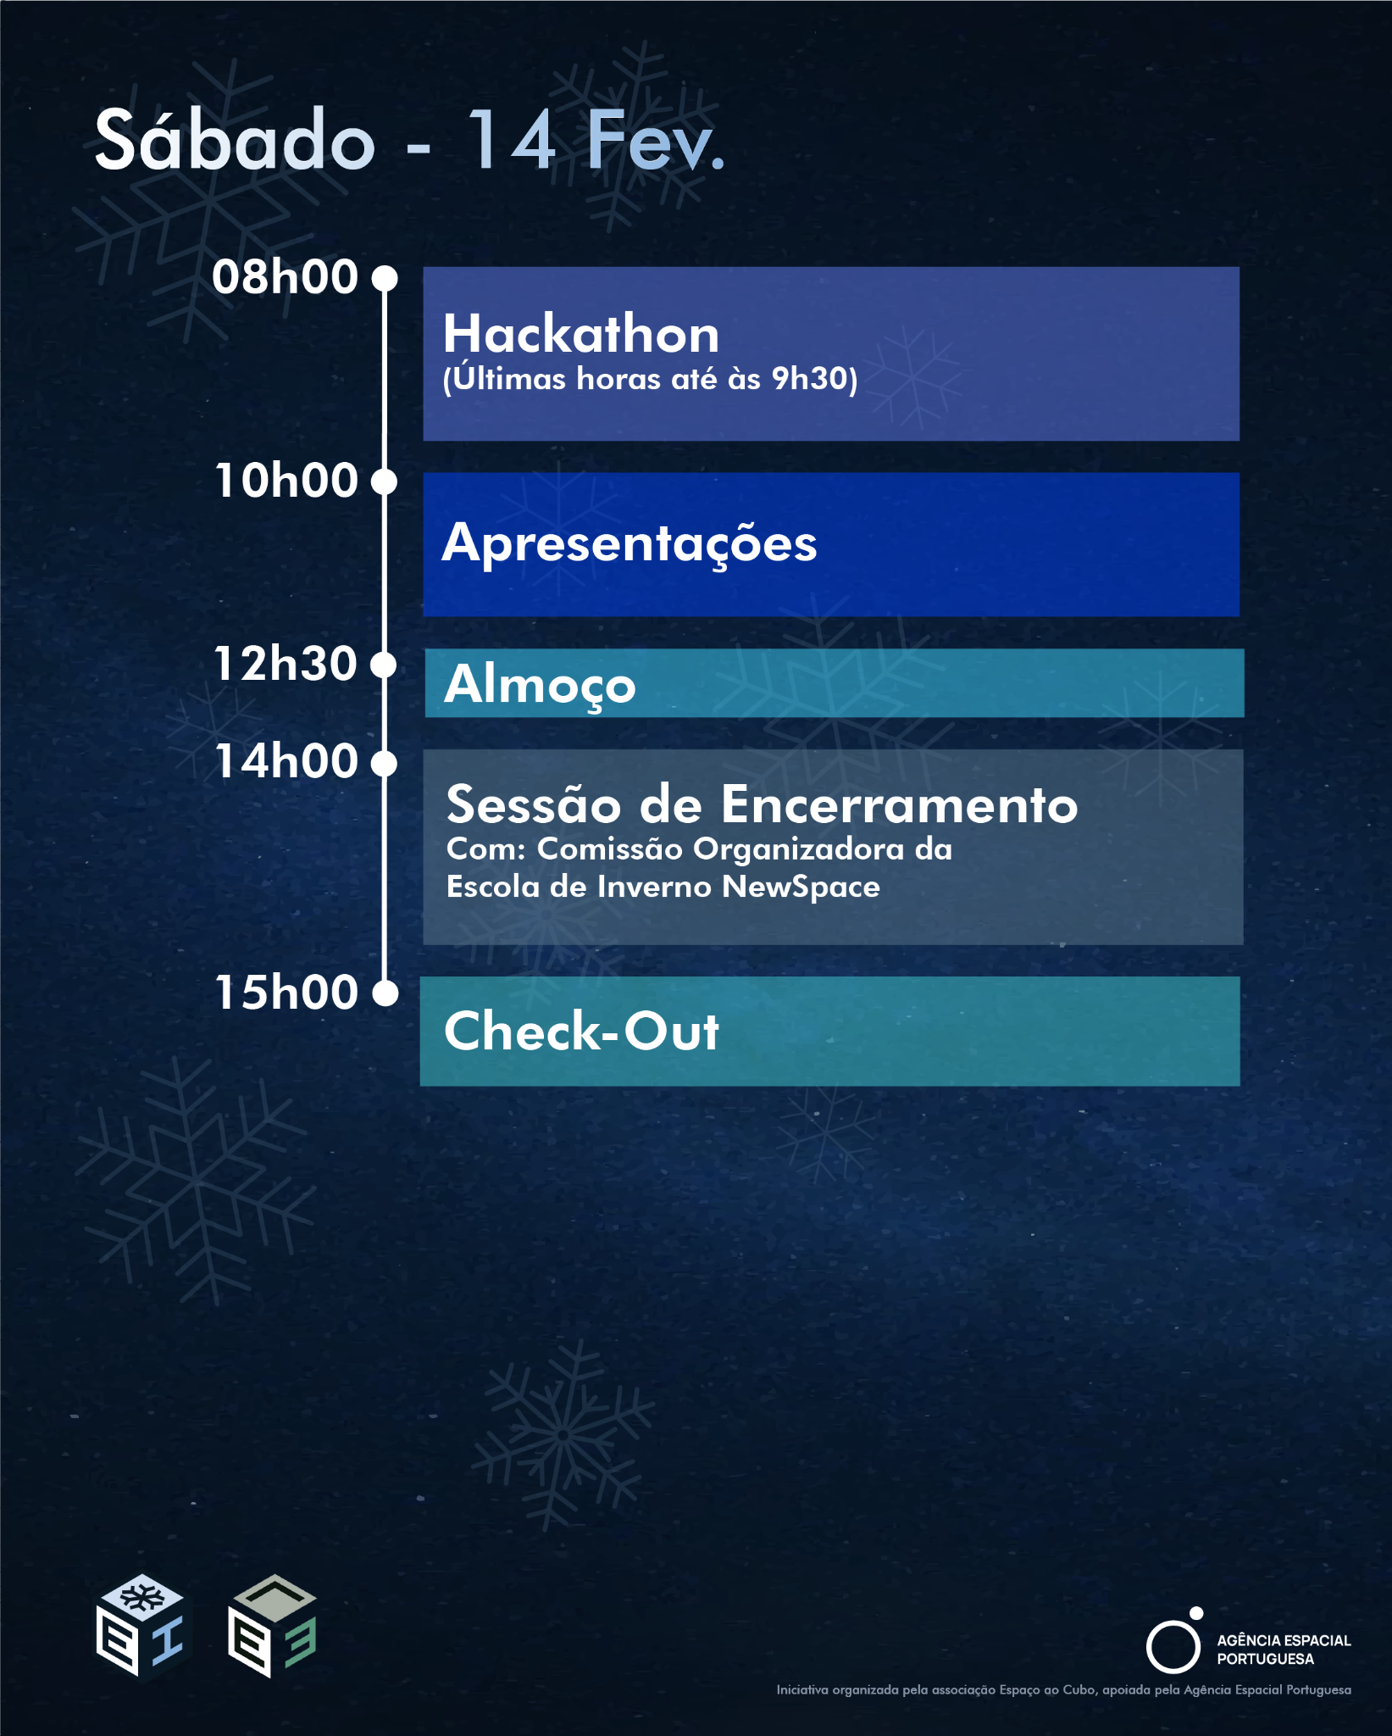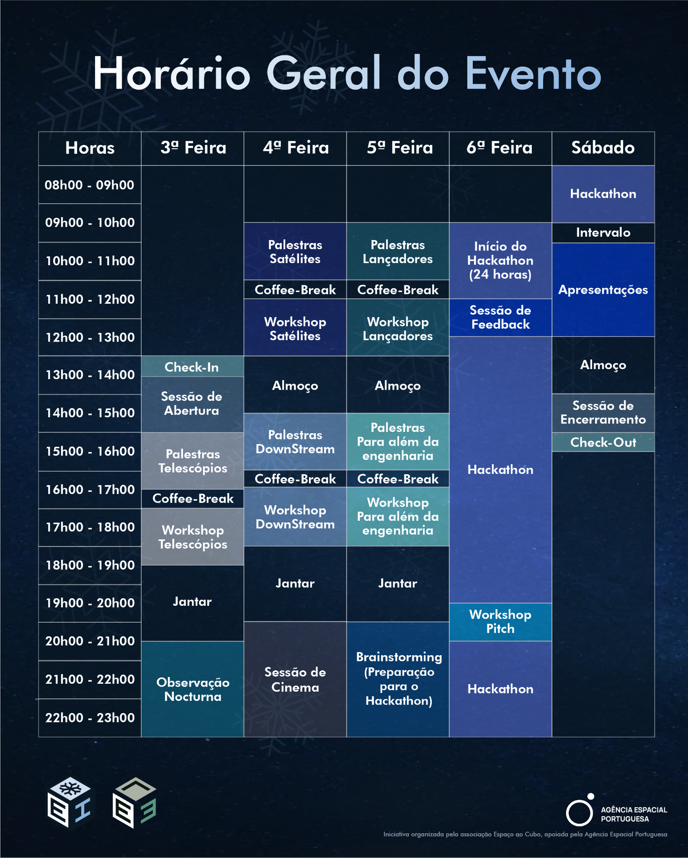

Speakers
Beyond Engineering

Gonçalo Vera-Cruz - foto
Descrição …

Sara Pinto Ferreira - foto e logos
Descrição …

Ana Prata - foto e logos
Descrição …

TELESCOPES
André Moitinho - fotos e logo
Descrição

Ricardo Ferreira - foto e logo
Descrição

Nuno Gonçalves - foto e logo
Descrição

SATELLITES
João Oliveira - Foto
Descrição…

N3O - fotos e logo
Descrições ….

DOWNSTREAM
Critical Software - foto e logos
Descrição

Thales - foto e logos
Descrição…

LAUNCH SYSTEMS
Alain - foto
Descriçao…

Omnidea - foto e logo
Descrição…

Francisco dos Santos - foto
Descrição…

Apoios/Patrocinios
Meter os logos

Contact
Have questions? Get in touch with us:
Email: space.school@espacoaocubo.pt
Social Media: @espacoaocubo

